**NAME : Izza Maryam**

**SAP ID :4936**

**DATABASE LAB 2:**

**TASK 1 :**

CREATE DATABASE Ecommerce;

CREATE TABLE USERS(

Id INT NOT NULL,

username VARCHAR(80) NOT NULL,

email VARCHAR(80) NOT NULL,

password VARCHAR(100) NOT NULL

);

INSERT INTO USERS

(Id,username,email,password)

VALUES

(1,"Ana","ABX@gmail.com","s005"),

(2,"Aima","lkus@gmail.com","aimadddd"),

(3,"Tayyaba","dwd@gmailcom","tttayab"),

(4,"Eman","werer@gmail.com","maan"),

(5,"Shaiza","fef@yahoo.com","shaiiii");

CREATE TABLE PRODUCTS(

NAME VARCHAR(100) NOT NULL,

DESCRIPTION VARCHAR(150) NOT NULL,

PRICE INT NOT NULL

);

INSERT INTO PRODUCTS

(NAME,DESCRIPTION,PRICE)

VALUES

("HU"," BLUE",76),

("FY","LAACK",55),

("TYUU JEANS","MEH",237),

("SADN","HEHY",4567),

("PERFUME","CHANEL ",456);

CREATE TABLE ORDERS(

ID INT NOT NULL,

USERID INT NOT NULL,

CREATED VARCHAR(60) NOT NULL,

TOATALPRICE INT NOT NULL

);

INSERT INTO ORDERS

(ID, USERID,CREATED,TOATALPRICE)

VALUES

(456,45678,"LAHORE",600),

(34,678,"KARACHI",3456),

(23,23488,"ITALY",3456),

(78,345,"TOKYO",45);

CREATE TABLE ORDERITEMS(

ID INT NOT NULL,

ORDERID INT NOT NULL,

PRODUCTID INT NOT NULL,

QUANTITY INT NOT NULL

);

INSERT INTO ORDERITEMS

(ID,ORDERID ,PRODUCTID,QUANTITY)

VALUES

(67,6787654,88,2),

(567,3456,12345,4),

(4567,3456,890,9),

(78,876543,345,1);

SELECT * FROM USERS,PRODUCTS,ORDERITEMS

**USERS TABLE :**

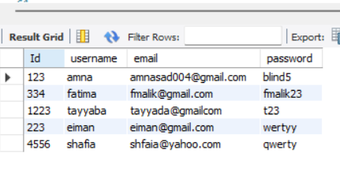

**PRODUCT TABLE :**

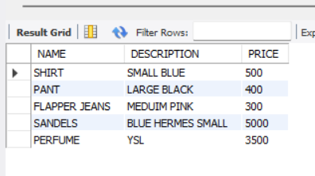

**TASK 2 :**

CREATE DATABASE Library;

USE Library;

CREATE TABLE BOOKS(

BOOKID INT PRIMARY KEY,

TITLE VARCHAR(100) NOT NULL,

AUTHOR VARCHAR(100) NOT NULL

);

INSERT INTO BOOKS

(BOOKID,TITLE,AUTHOR)

VALUES

(1,"EMPIRE","RINA KENT"),

(2,"OUR FAULT","MERCEDES RON"),

(3,"FORTY RUES OF LOVE","ELF SHAFAK");

CREATE TABLE MEMBERS(

MEMBERID INT PRIMARY KEY,

FIRSTNAME VARCHAR(50) NOT NULL,

LASTNAME VARCHAR(50) NOT NULL,

JOINDATE INT NOT NULL

);

INSERT INTO MEMBERS

(MEMBERID,FIRSTNAME,LASTNAME,JOINDATE)

VALUES

(5,"AMNA","ASAD",33),

(3,"SHAFIA","MURAD",04),

(6,"FATIMA","MALIK",23);

CREATE TABLE ENROLLMENT(

ENROLLMENTID INT PRIMARY KEY,

STUDENTID INT NOT NULL,

COURSEID INT NOT NULL

);

INSERT INTO ENROLLMENT

(ENROLLMENTID,STUDENTID,COURSEID)

VALUES

(1234,3456,4567),

(5678,49297,6432),

(234,49296,09812);

CREATE TABLE DEPARTMENT(

DEPARTMENTID INT PRIMARY KEY,

NAME VARCHAR(100) NOT NULL

);

INSERT INTO DEPARTMENT

(DEPARTMENTID,NAME)

VALUES

(0975,"FACULTY OF COMPUTING"),

(97661,"DEPARMENT OF REHBLITATION");

CREATE TABLE EMPLOYEES(

EMPLOYEEID INT PRIMARY KEY,

FIRSTNAME VARCHAR(50) NOT NULL,

LASTNAME VARCHAR(50) NOT NULL,

HIREDATE INT NOT NULL

);

INSERT INTO EMPLOYEES

(EMPLOYEEID,FIRSTNAME,LASTNAME,HIREDATE)

VALUES

(12,"MAN","AHEMED",20),

(44,"TAYYABA","REHAMN",18),

(76,"AYESHA","FARHAT",31);

DROP TABLE MEMBERS;

SELECT * FROM EMPLOYEES;

SELECT * FROM BOOKS

BOOKS TABLE:

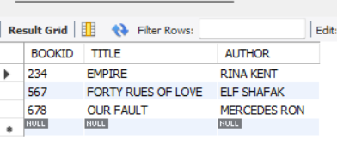

ENROLLMENT TABLE :

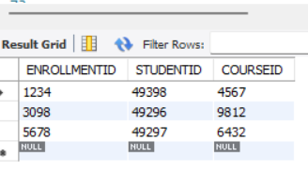

DEPARTMENT TABLE :

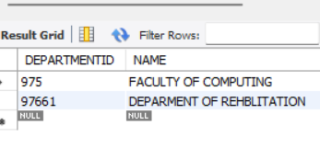

EMPLOYEES TABLE :

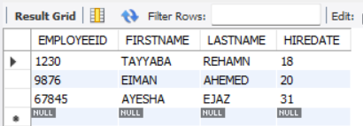

Which SQL data type would you use for storing a phone number and why?

Both integer and varchar datatypes can be used to store phone numbers; if the numbers don't contain any signs like + or -, we should use integers; however, if the numbers do contain signs or brackets, we should use varchar since it can store numbers that are coupled with characters.